**LOCAL ANGELS - an initiative by ‘Team Swasthya’**

**World Innovation Day Hack - Health and Well Being**

**April 16 - April 19, 2021**

**Coronavirus Cases in India (COVID-19)**

**(**[**https://www.statista.com/topics/6135/coronavirus-covid-19-outbreak-in-india/**](https://www.statista.com/topics/6135/coronavirus-covid-19-outbreak-in-india/)**)**

It all started in January 2020 when three Indian students travelled to Kerala from Wuhan in China (epicenter of coronavirus) and tested positive. Since then, the infections increased rapidly from March until today.

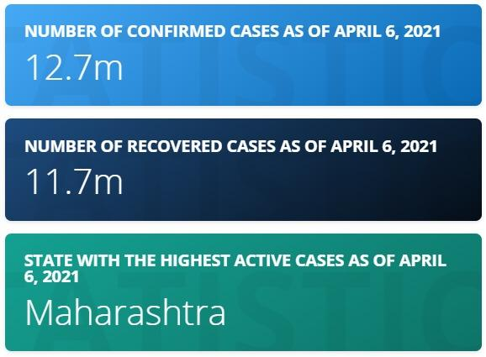

**Overview of COVID-19 in India: (**[**https://www.statista.com/statistics/1111149/india-opinion-on-coronavirus-fears-and-concerns/**](https://www.statista.com/statistics/1111149/india-opinion-on-coronavirus-fears-and-concerns/)**)**

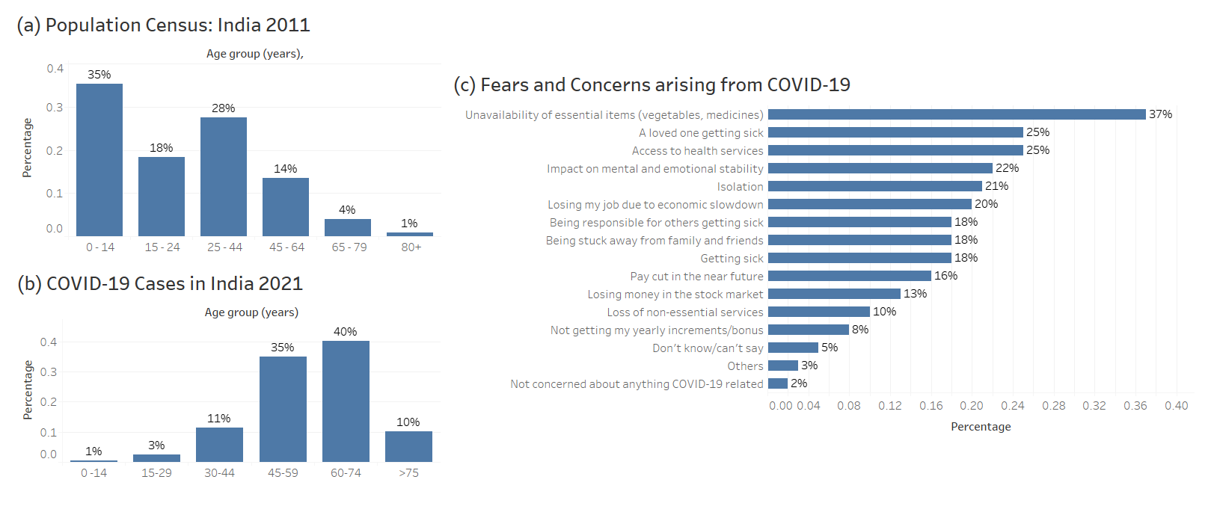

Population census (2011) and COVID-19 cases (2021) are shown above.

**Observations:**

1. 81% of India’s population fall in the age group below 44.
2. 85% of COVID-19 cases in India fall in the age group 45 and above
3. Top 3 fears are related to unavailability of essential items (vegetables, medicines), a loved one getting sick, access to health services and impact on mental and emotional stability

**Why do we choose this approach?**

1. The 2011 India Census shows that 81% of the population falls below 44 years of age.
2. COVID-19 data from various sources such as John Hopkins State University notifies that 85% of the COVID-19 cases fall in the age group 45 and above.
3. Our app ‘Local Angels’ makes use of the Human to Human (H2H) approach. Based on the points 1 and 2 above, it is evident that 85% of the elderly (45+) people will need help/assistance and they cannot travel outside based on the COVID-19 protocol.
4. Since 81% of the younger population (below 44) is least affected by COVID-19, they can serve as volunteers and help the elderly people. Hence Local Angels have a great potential to serve the needy people.

**How will it be a success?**

A survey among 1000 adult online population between April 7 to 10, 2021 and the results are as below:

1. 37% of the adults had a fear that they would not be available to access the essential items like vegetables and medicines.
2. 25% of the respondents were concerned about their loved one falling sick and that they won't have any access to health services.

In India, most of the monetary transactions require hard cash and hence people cannot pay online. They would need to go to Banks/ ATMs to cash out the money. People cannot leave their home when they are sick. As a result, they cannot purchase essential items like vegetables and medicine as shown in the data above.

25% of the people think that they cannot access health services which in turns lead to anxiety and causes mental and emotional stability.

Our main focus of H2H is to connect volunteers to the people in need which can help to solve the major chunk of the fear arising due to the pandemic.

We aim to cater the needs of the people in need as well as help them emotionally by connecting them with local volunteers and thus want to give a strong message that “People need People”.

**Partners, Sponsors and Need**

**A. Volunteer groups in India**

1. **Medical Volunteer Program**: Mobile vans to provide free health check-up, treatment of general sickness, STI Treatment & HIV/AIDS Counseling and Education Services. (<https://volunteeringwithindia.org/volunteering-program-in-india/>)
2. **International Volunteer HQ [IVHQ]:** Volunteers perform more hands-on task such as  minor injuries as well as cleaning and bandaging wounds. (<https://www.goabroad.com/providers/international-volunteer-hq/programs/volunteer-in-healthcare-in-india-111262>)
3. **Smile Foundation India**: 34 operational projects in 478 remote villages and slums. Program that seeks to address problems of mobility, accessibility, and availability of primary healthcare with a special focus on children and women, in urban slums and remote rural areas. (<https://www.smilefoundationindia.org/smile_on_wheels.html>)

**B. Sponsors/Investors in Healthcare startups in India:**

1. **Aavishkar Group**: Venture capital approach of investing in early-growth stage enterprises in India. Impacted 105Mn lives until now. Focus on deep-rooted and ignored problems. (<https://aavishkaarcapital.in/about#invstmnt_apprch_scroll>)
2. **Startup India**: Flagship initiative of Government of India intended to build a strong eco-system for nurturing innovation. Aims to empower startups to grow through innovation and design. (<https://www.startupindia.gov.in/>)
3. **Make in India – Wellness:** India is one of the pioneers in the alternative system of medicine. Over USD 200Bn to be spent on medical infrastructure by 2024. Infrastructure developed comprising of 13.8 lakh registered practitioners, 3986 Hospitals and 27,199 Dispensaries (<https://www.makeinindia.com/sector/wellness>)

**C. India Healthcare Market Size and reach:**

(<https://www.ibef.org/industry/healthcare-india.aspx>)

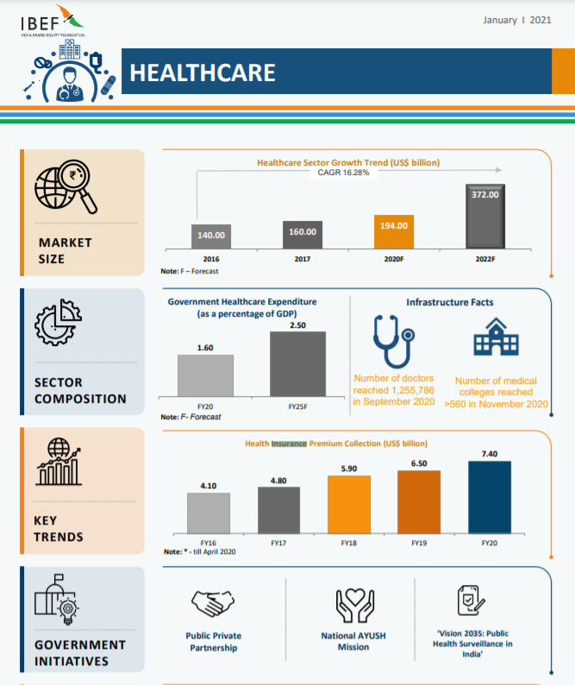

**Strong Demand**: Healthcare market in India to reach US$327 billion by 2022 driven by increasing income, better health awareness, lifestyle diseases and increasing access to insurance.

**Rising Manpower and Medical Colleges**: Availability of large pool of well-trained medical professionals.

**Government support**: The government has placed a purchase order with Serum Institute of India (SII) for 11 million doses of Oxford COVID-19 vaccine, Covishield, to prepare for the world’s largest ‘COVID-19 vaccination campaign’.

**Attractive Opportunities**: The Government of India aims to increase healthcare spending to 3% of the Gross Domestic Product (GDP) by 2022.

**D. Road ahead:**

1. **Aarogya Setu Initiative:** We have a plan to tie-up with the Government of India Aarogya Setu app which has 17,56,00,000 downloads and helps in identification and prevention of potential virus.
2. The hospital industry in India is forecast to increase to Rs. 8.6 trillion (US$ 132.84 billion) by FY22 from Rs. 4 trillion (US$ 61.79 billion) in FY17 at a CAGR of 16–17%. (<https://www.ibef.org/industry/healthcare-india.aspx>)
3. The Government of India is planning to increase public health spending to 2.5% of the country's GDP by 2025. We are anticipating getting funding from various government initiatives like startup India, make in India initiative, etc. (<https://www.ibef.org/industry/healthcare-india.aspx>)

**E. Competitors:**

**Local Competitors:**

1. **Donate my Time (DMT):** The app links volunteers to NGO’s and has 1000+ downloads in 3 years (around 400 downloads per year).

**Global Competitors:**

1. **Point App:** The app is available only in Ohio for now. The app notifies about volunteer events near you, allows to meet volunteers nearby and helps to find NGO’s nearby and has 1000+ downloads in 3 years (around 500 downloads per year)

**Value Proposition (**[**https://www.grandviewresearch.com/industry-analysis/india-home-healthcare-market**](https://www.grandviewresearch.com/industry-analysis/india-home-healthcare-market)**)**

The homecare business comes as a boon for the already burdened healthcare infrastructure in India. There is significant demand-supply gap plaguing the Indian healthcare system - while India accounts for 20% of the global disease burden, it accounts for only 6% of global hospital beds and 8% share of doctors and nursing staff. Home healthcare concept complements the healthcare delivery by reducing the average length of stay, ensuring efficient utilization of existing bed capacity and reducing chances of readmission. They can also improve the average revenue per occupied bed if they work out the synergy in the right manner with the homecare providers.

The patients and their families are also increasingly adopting healthcare services at home. It provides the comfort of home and saves the physical and psychological pressure of hospital visits and stays. Home healthcare service is also more affordable than hospital stays. With savings on real estate and infrastructure cost, the model operates at ~15-30% lower cost when compared to hospital expenses for similar treatment.

For Apollo, depending on the nature of the service, the cost could range between Rs 2,000 to Rs 3,600 for a 24-hour attendance. With life expectancy increasing significantly in India, home health care is becoming mandatory. The concept of old-age homes or assisted living is socially largely unacceptable in India and therefore there is huge demand for home-based health care facilities. It is also finding great flavor with expats who have parents at home in India and are looking for professional healthcare for them at the convenience of home.

**Oracle database for the Local Angles App:**

**(**[**https://github.com/pvmedu/wid_hackathon**](https://github.com/pvmedu/wid_hackathon)**)**

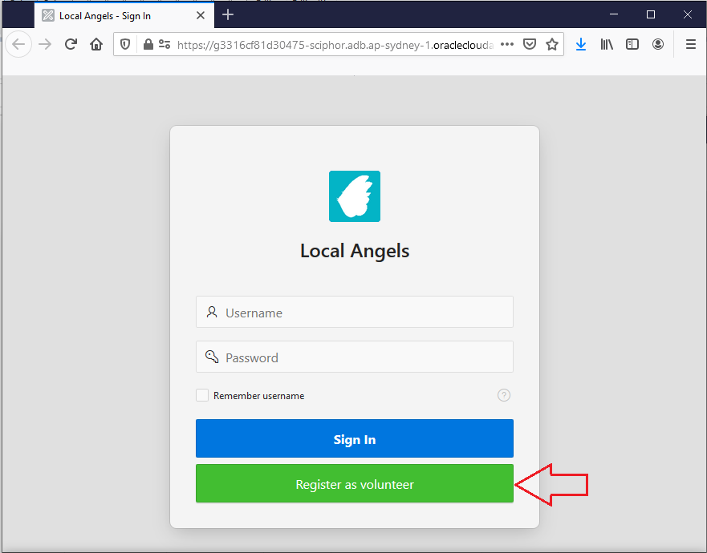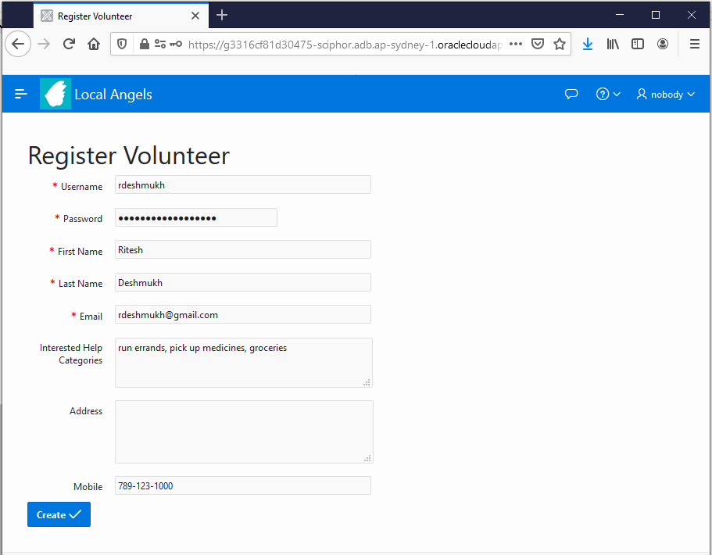

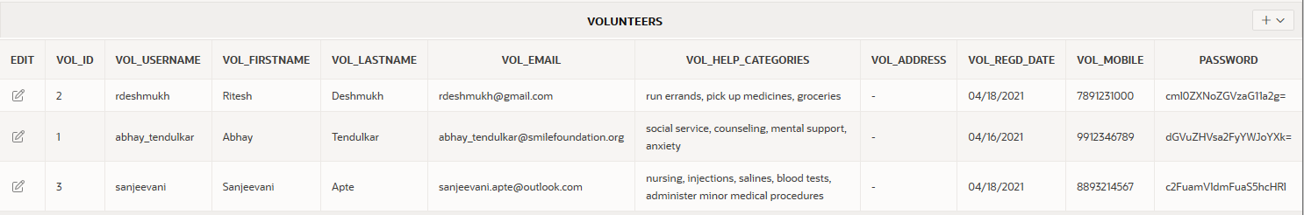

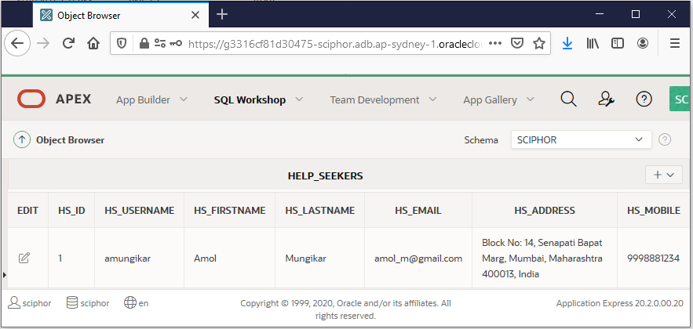

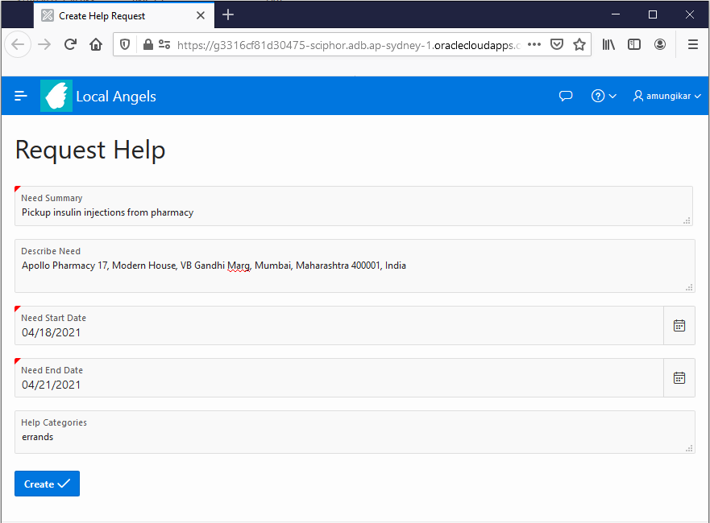

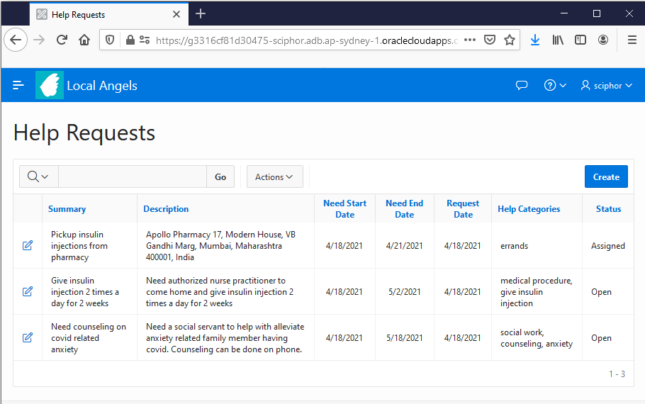

**App made in** [**https://bubble.io/home**](https://bubble.io/home)

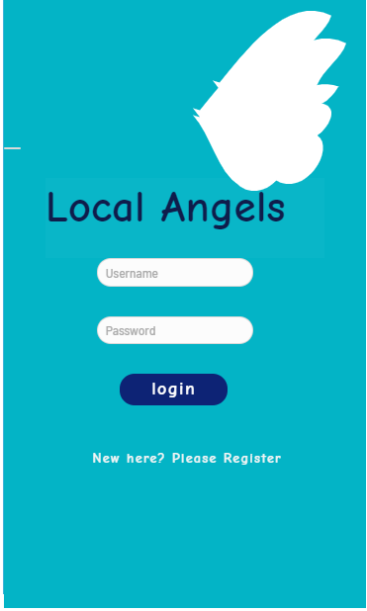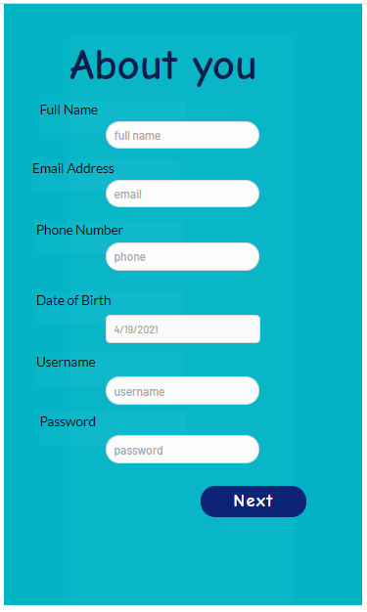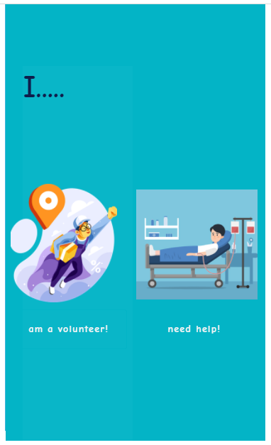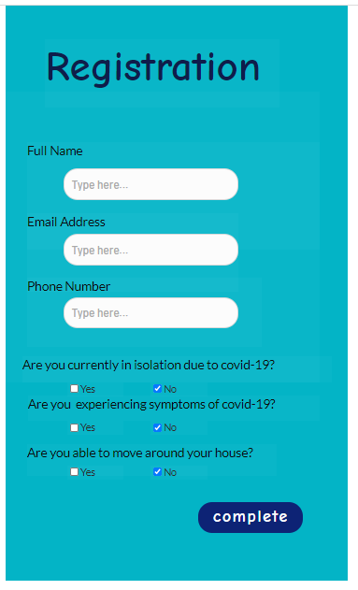

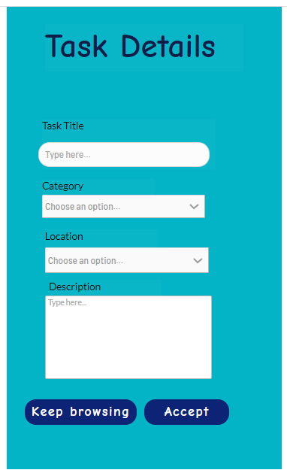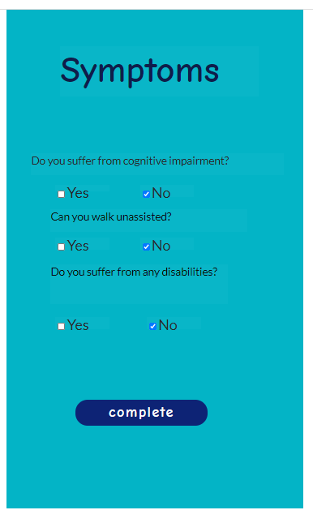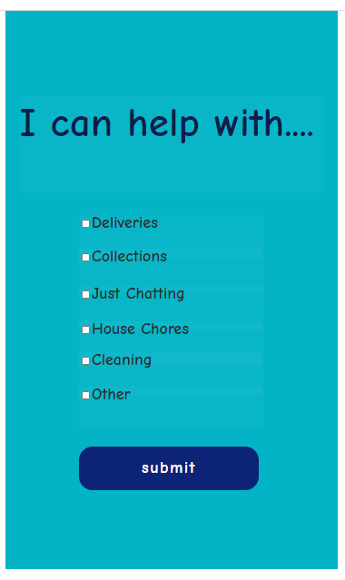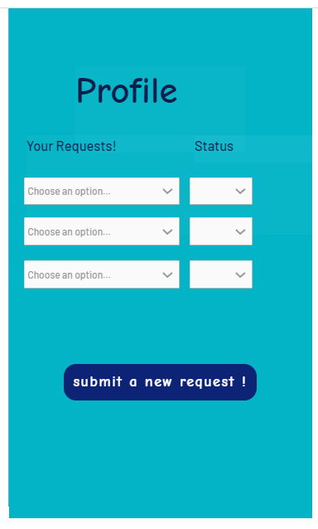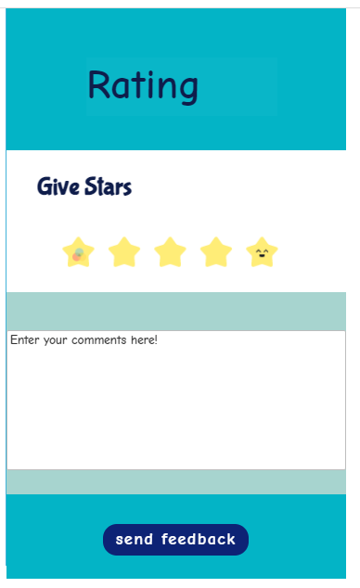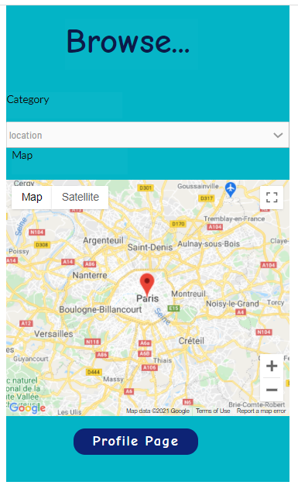

**Prototype in Adobe XD**

<https://xd.adobe.com/view/c222d0af-75e8-47b8-8967-225ca8ed922d-9771/>

